

ISLAMIC UNIVERSITY OF TECHNOLOGY (IUT)
ORGANISATION OF ISLAMIC COOPERATION (OIC)
Department of Computer Science and Engineering (CSE)

QUIZ 3 STATISTICS

Average Breakdown

Problem |  | Avg | Out of | Percentage (%) | Avg | Out of | Percentage (%)
Priority Encoder |  | 3.33 | 4.5 | 73.89 | 3.33 | 4.5 | 73.89
Comparator | Diagram | 4.17 | 7 | 59.59 | 6.29 | 10 | 62.92
 | IC Count | 0.57 | 1 | 57.41
 | Explanation | 1.06 | 2 | 52.78
 | Efficient Solution | 0.49 | 5 | 9.81
PLD | Solving problem | 2.98 | 3.5 | 85.05 | 4.71 | 5.5 | 85.69
 | MCQ | 1.74 | 2 | 86.81
Total |  | 14.33 | 20 | 71.65 | 14.33 | 20 | 71.65

Attempts

Problem |  | Attempts | Out of | Percentage (%)
Priority Encoder |  | 52 | 54 | 96.30
Comparator | Diagram | 47 |  | 87.04
 | IC Count | 31 |  | 57.41
 | Explanation | 36 |  | 66.67
 | Efficient Solution | 8 |  | 14.81
PLD | Solving problem | 50 |  | 92.59
 | MCQ | 54 |  | 100.00

Performance Graph

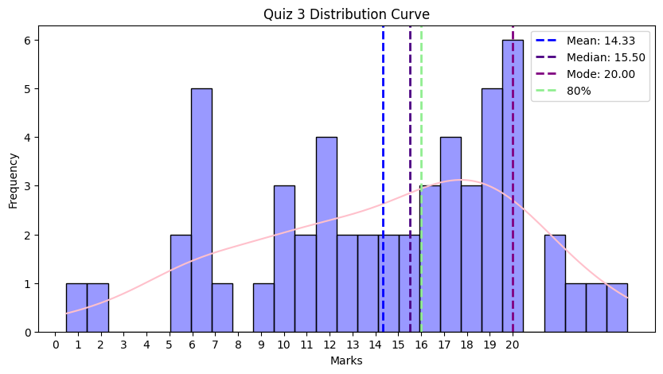

Full Marks

Problem |  | Perfect Score |  | Out of | Percentage (%) | Percentage (%)
Priority Encoder |  | 24 | 24 | 54 | 44.44 | 44.44
Comparator | Diagram | 16 | 17 |  | 29.63 | 31.48
 | IC Count | 28 |  |  | 51.85
 | Explanation | 21 |  |  | 38.89
 | Efficient Solution | 3 |  |  | 5.56
PLD | Solving problem | 39 | 30 |  | 72.22 | 55.56
 | MCQ | 35 |  |  | 64.81

Leaderboard
Serial | ID | Name | Marks
1 | 230042143 | Wasi Omar Syed | 25
2 | 230042109 | Tamjidur Rahman | 24
3 | 230042139 | Sayma Tasnim | 23
4 | 230042119 | Talha Zubayer | 22
5 | 230042125 | Ittesaf Yeasir Ithun | 21.5
6 | 230042120 | Safia Aman Anika | 20
7 | 230042134 | S. M. Raiyan Al Arafat | 20
8 | 230042135 | Khadiza Sultana | 20
9 | 230042154 | Aksan Anan Ria | 20

Comebacks

Serial | ID | Name | Marks
1 | 230042119 | Talha Zubayer | 10.5
2 | 230042143 | Wasi Omar Syed | 9.5
3 | 230042154 | Aksan Anan Ria | 8.75
4 | 230042134 | S. M. Raiyan Al Arafat | 8.5
5 | 230042109 | Tamjidur Rahman | 7.75
6 | 230042107 | Md. Faiyaz Tahmid | 7

Unnecessary Statistics
- There was a 5 marks bonus, so the total mark was 25. The bonus mark will be adjusted somewhere if you got over 20.
- 1 student got a perfect score, 9 got above 20.
- 36 students got more in quiz 3 than quiz 1 and quiz 2 on average.
- One student did not write down their ID in the answer script so it will be distributed among 3 random students.
- This was the highest average out of the three quizzes (originally out of 25). However, when scaled to 20, it becomes the lowest performance among the three.
- Bonus –
  - If you attended the quiz and you didn’t get 0 → bonus 0.25 attendance mark.
  - If you attended the quiz and got more than the class average → bonus 0.5 attendance mark.
  - If you attended the quiz and got more than 80% marks (16) → bonus 1 attendance mark.

Few Things to be noted
- Read the question carefully.

